TRAINING REPORT
ON
FRUIT PLANTATION AND MANAGEMENT TRAINING
Conducted across all wards (Ward Nos. 1–7) of Gaumukhi Rural Municipality
Pyuthan, Nepal

Conducted Under:
Sustainable Home Garden Initiative Project
(दिगो घरबारी बगैंचा पहल कार्यक्रम)
IMPLEMENTING AGENCY:  SAHAVAGI  Field Office:  Gaumukhi-05, Thulabesi, Pyuthan | FINANCIAL SUPPORT:  Gaumukhi Rural Municipality  Office of the Rural Municipal Executive  Pyuthan, Lumbini Province, Nepal

PREPARED BY: Nishan Khatri
Field Coordinator
SAHAVAGI
DATE OF SUBMISSION: June 2026

SAHAVAGI
Field Office
Gaumukhi-05, Thulabesi, Pyuthan

1.Introduction
Fruit cultivation plays an important role in improving household nutrition, increasing income opportunities, and promoting sustainable agricultural practices. With the objective of enhancing farmers’ knowledge and skills on proper fruit plantation and management techniques, and with the financial support of Gaumukhi Rural Municipality, Fruit Plantation and Management Training was conducted in all wards (Ward No. 1–7) of Gaumukhi Rural Municipality from June 21 to June 25, 2026. The training mainly focused on the importance of fruit cultivation, site selection, pit preparation, fruit planting procedures, and post-plantation care and management practices. The sessions in Wards 1 and 2 were facilitated by Mr. Ramkrishna Ghimire, Agriculture Expert, while the trainings in the remaining five wards were facilitated by Field Coordinator Nishan Khatri and Social Mobilizer Kashyap Puri. The training was conducted at the local community level to ensure greater accessibility and participation of farmers. Although the initial target was 140 farmers, a total of 174 farmers participated in the training, demonstrating the strong interest and active engagement of local farmers in the training program.
2.Objectives
- To enhance farmers’ knowledge and skills on scientific fruit plantation and management practices.
- To increase awareness on the importance of fruit cultivation for nutrition, income generation, and sustainable livelihoods.
- To build farmers’ capacity on proper site selection, pit preparation, planting techniques, and post-plantation care of fruit saplings

3.Training Contents
- Introduction to Fruit Cultivation and Its Importance
- Classification of Fruit Crops According to Altitude and Agro-Climatic Conditions
- Site Selection and Orchard Planning
- Plant Spacing and Orchard Layout
- Pit Preparation Techniques for Fruit Plantation
- Fruit Sapling Planting Methods and Procedures
- Post-Planting Care and Management Practices
- Manure and Fertilizer Management
- Irrigation Management
- Training and Pruning of Fruit Trees
- Disease and Insect Pest Management
- Fruit Drop: Causes and Management Practices
- Orchard Protection and Maintenance Measures
- Annual Orchard Management Calendar
- Preparation and Application of Bordeaux Mixture and Bordeaux Paste
- Field Demonstration on Pit Preparation, Pruning, Use of Pheromone Trap and Orchard Management Practices,
4.Methodology
The training was conducted at the community level in all seven wards of Gaumukhi Rural Municipality, with one day of training organized in each ward. A participatory and practical learning approach was adopted to ensure active engagement of farmers throughout the sessions. Training was delivered through interactive discussions, experience sharing, question-and-answer sessions, and the use of visual materials such as chart papers and other training aids to enhance understanding. Field demonstrations were conducted on key topics including pit preparation, fruit sapling planting techniques, pruning, and orchard management practices. Farmers were encouraged to discuss local challenges and share their experiences related to fruit cultivation, enabling a more practical and context-specific learning process.
5. Trainers
- Ramkrishna Ghimire, Agriculture Expert, SAHAVAGI
- Nishan Khatri, Field Coordinator, SAHAVAGI
- Kashyap Puri, SM-Agriculture
6. Training Achievements
- A total of 160 farmers (against the target of 140) actively participated in the Fruit Plantation and Management Training conducted across all seven wards of Gaumukhi Rural Municipality.
- Participants gained a better understanding of the importance of fruit cultivation for improving household nutrition, income generation, and long-term livelihood security.
- Farmers enhanced their knowledge on scientific orchard establishment, including site selection, orchard planning and plant spacing.
- Participants committed to adopting recommended practices such as digging planting pits at least one month before plantation and ensuring proper pit preparation for healthy plant growth.
- Farmers improved their understanding of manure and fertilizer management, including the appropriate use of organic manure and balanced nutrient application for fruit crops.
- Participants gained practical knowledge on post-planting care and management, including staking, irrigation, mulching, protection of young plants, and regular orchard maintenance.
- Farmers learned the importance and techniques of training and pruning fruit trees to improve plant structure, productivity, and orchard management.
- Participants enhanced their knowledge of integrated pest and disease management, including the installation and use of pheromone traps and other preventive measures.
- Farmers learned the causes of fruit drop and appropriate management practices to reduce losses and improve fruit production.
- Participants acquired practical skills in the preparation and application of Bordeaux Mixture and Bordeaux Paste for the prevention and management of common diseases in fruit crops.
7. Participant Feedback
Participants expressed that the field-level training approach was highly effective as it allowed them to learn directly in a practical setting and relate the knowledge to their own farming conditions. They appreciated the use of demonstrations, visual materials, and interactive discussions, which made the training easier to understand compared to classroom-based sessions. Farmers reported that they gained valuable knowledge on fruit plantation, orchard management, pruning, nutrient management, and pest and disease control. Participants also suggested conducting refresher trainings in the future to reinforce learning and update them on improved practices. In addition, they emphasized the importance of regular follow-up visits and technical support from facilitators to help them apply the recommended practices effectively in their orchards.
8. Conclusion
The Fruit Plantation and Management Training was successfully conducted in all seven wards of Gaumukhi Rural Municipality with active participation from 174 farmers, exceeding the initial target. The training enhanced farmers’ knowledge and practical skills on scientific fruit cultivation, orchard establishment, nutrient management, pruning, pest and disease management, and post-plantation care. Through interactive discussions and field demonstrations, participants gained confidence in adopting improved fruit production practices in their own orchards. The high level of participation and positive feedback received from farmers demonstrated the relevance and effectiveness of the training. It is expected that the knowledge and skills gained through the training will contribute to the successful establishment and management of fruit orchards, ultimately improving household nutrition, income generation, and sustainable livelihoods in the municipality.

9. Photo Plates
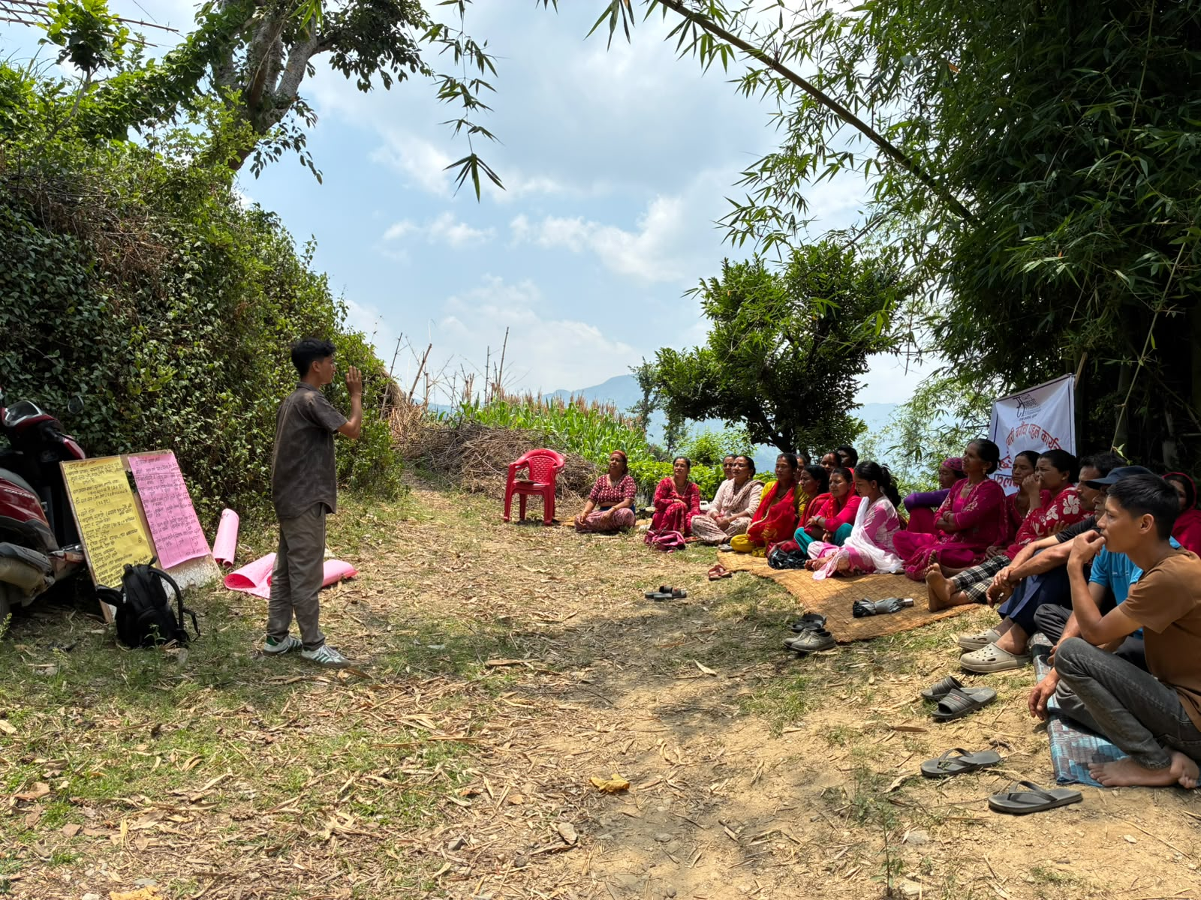
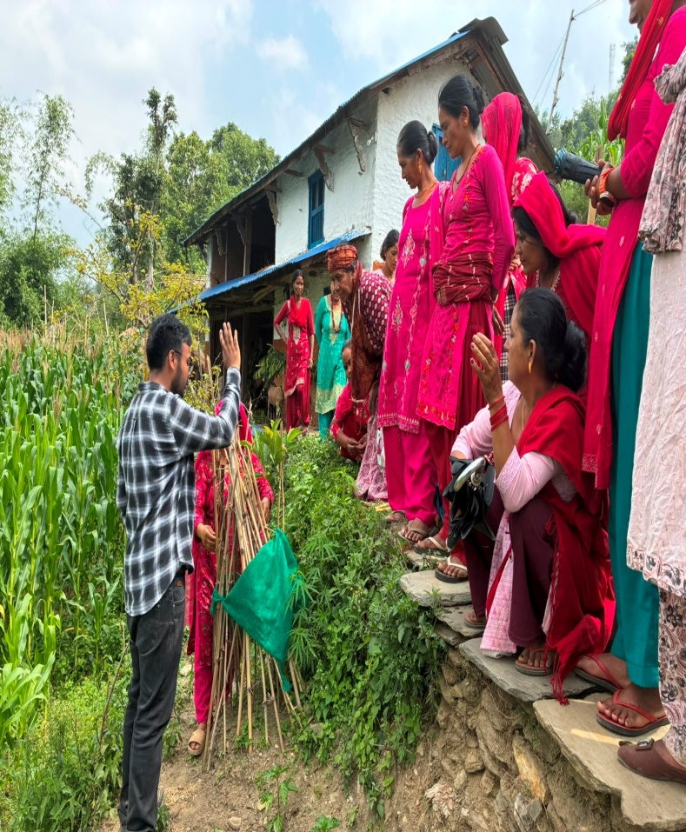
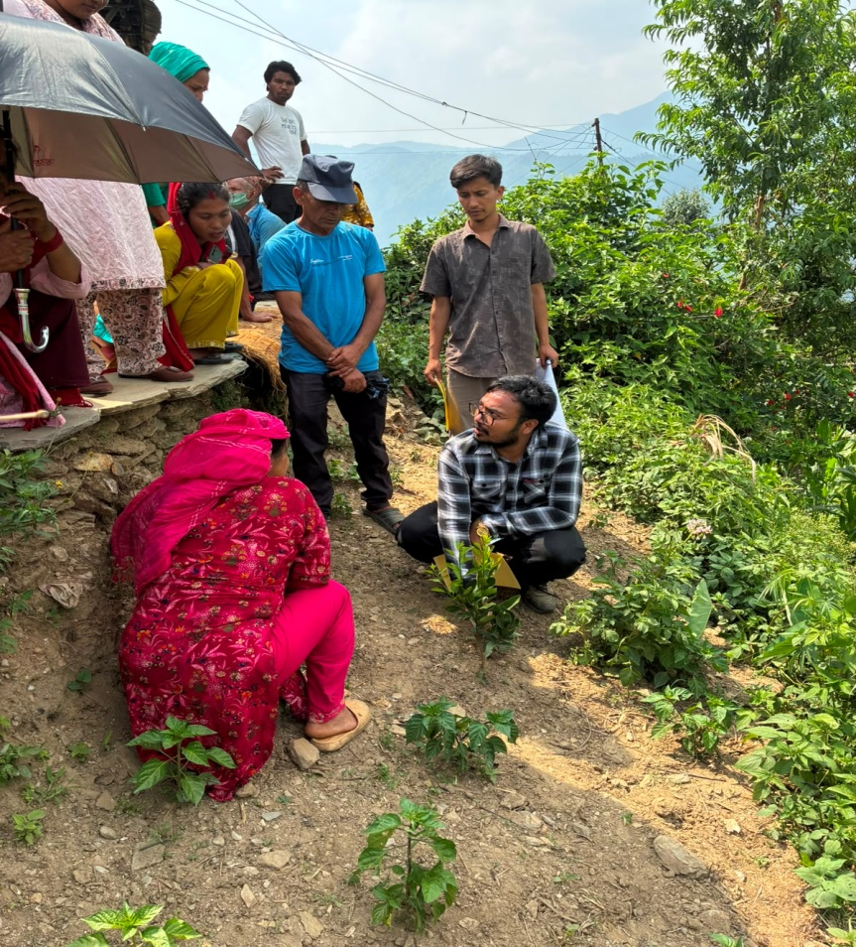
A glimpse of training at Narikot, Gaumukhi-7
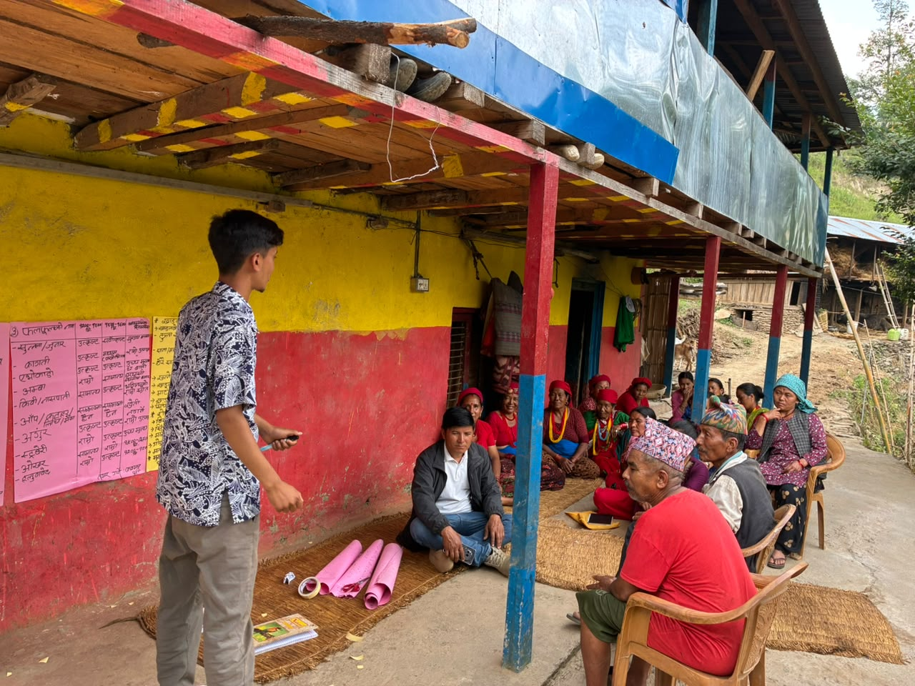
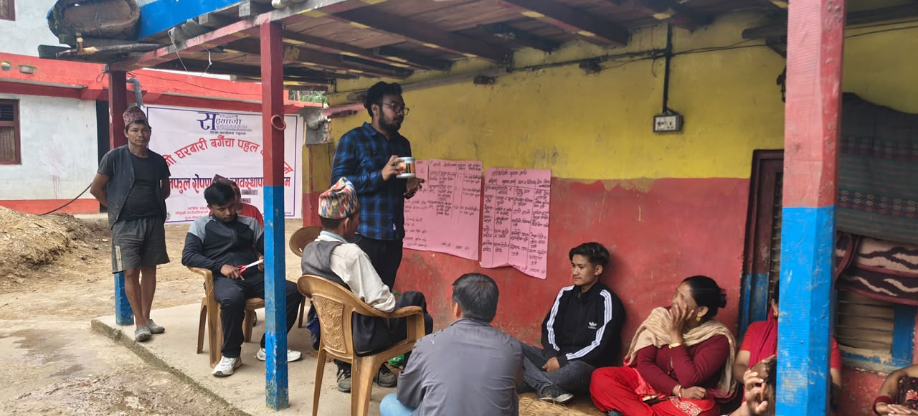
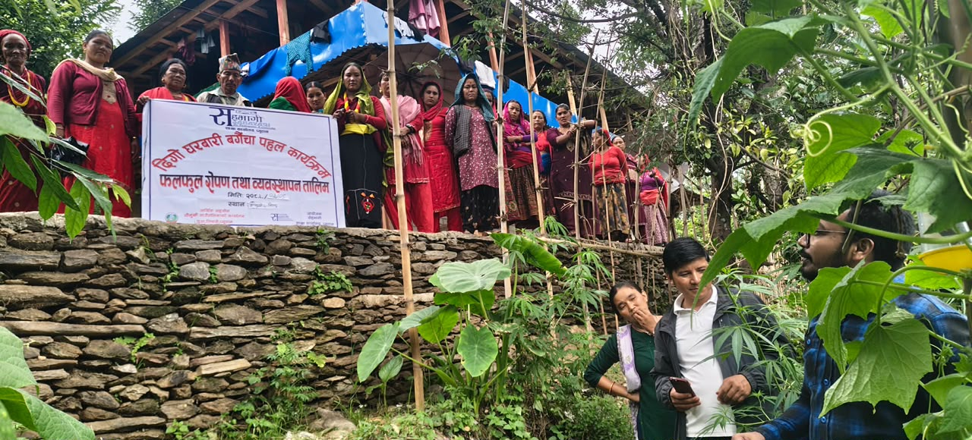

A glimpse of training at Lebang, Gaumukhi-6

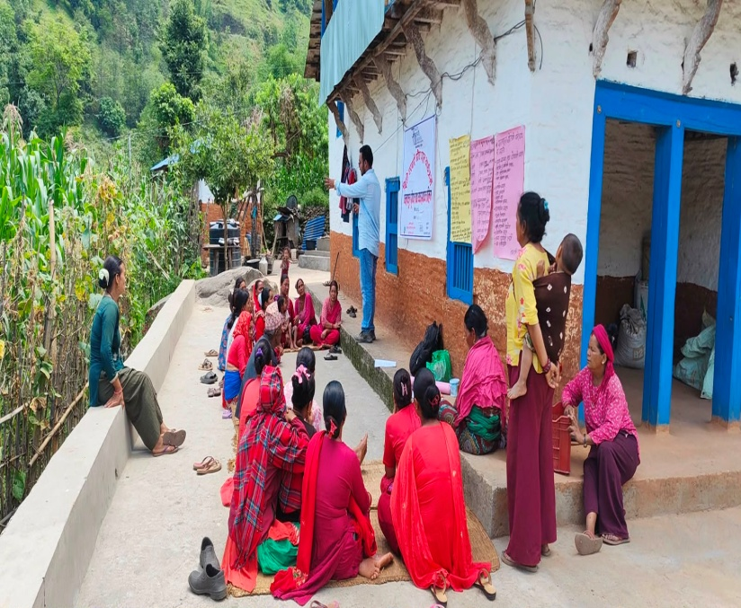
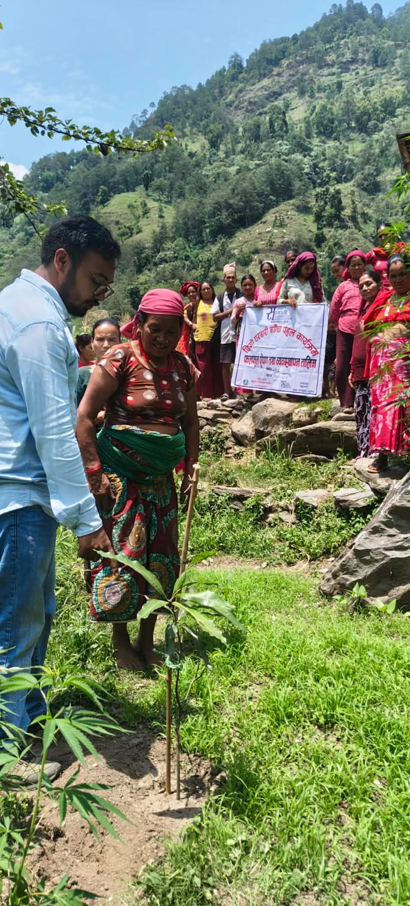
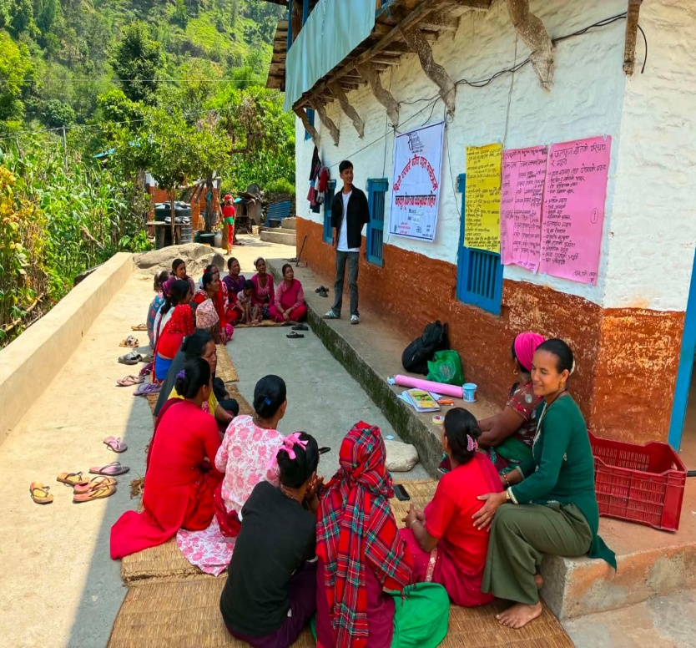
A glimpse of training at Dasmure, Gaumukhi-5

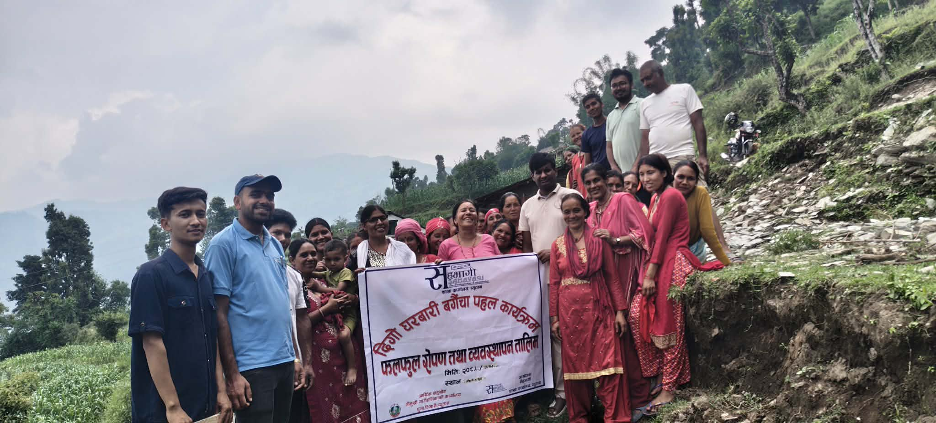
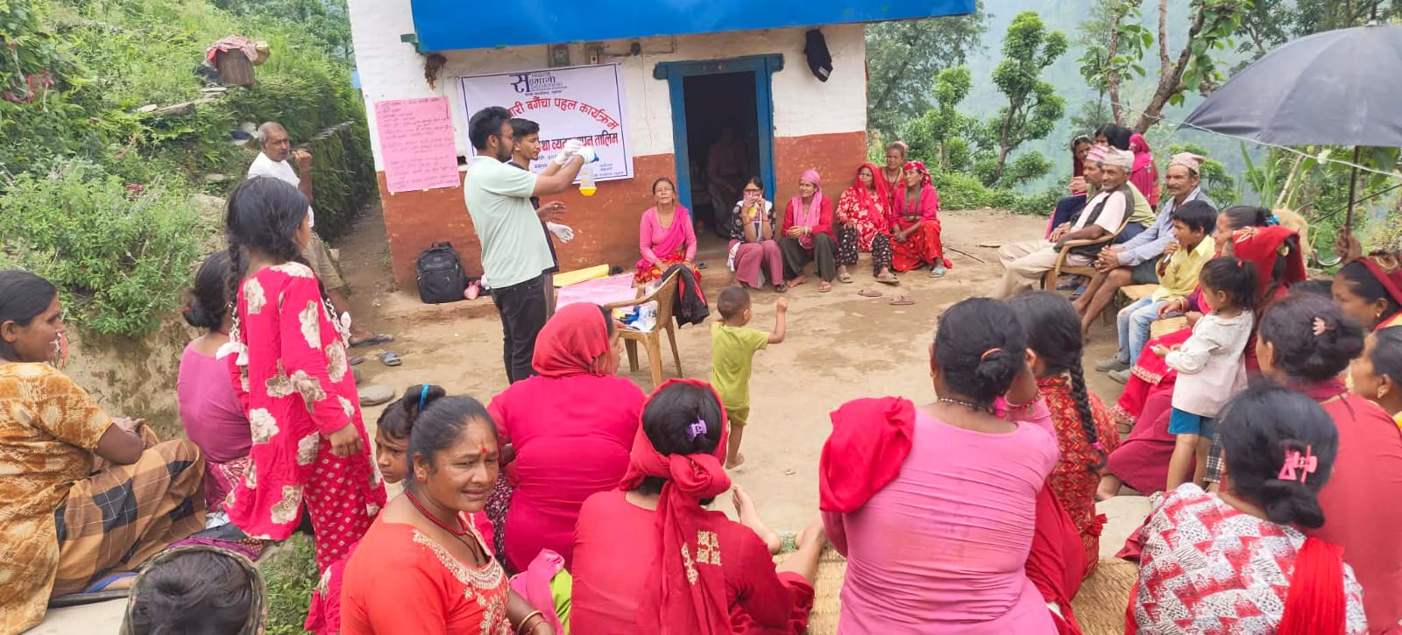
Demonstration of the Methyl Eugenol Pheromone Trap Preparation – For Citrus Fruit Drop

Group Photo with Agriculture Section Representatives – Gaumukhi -4, Puja

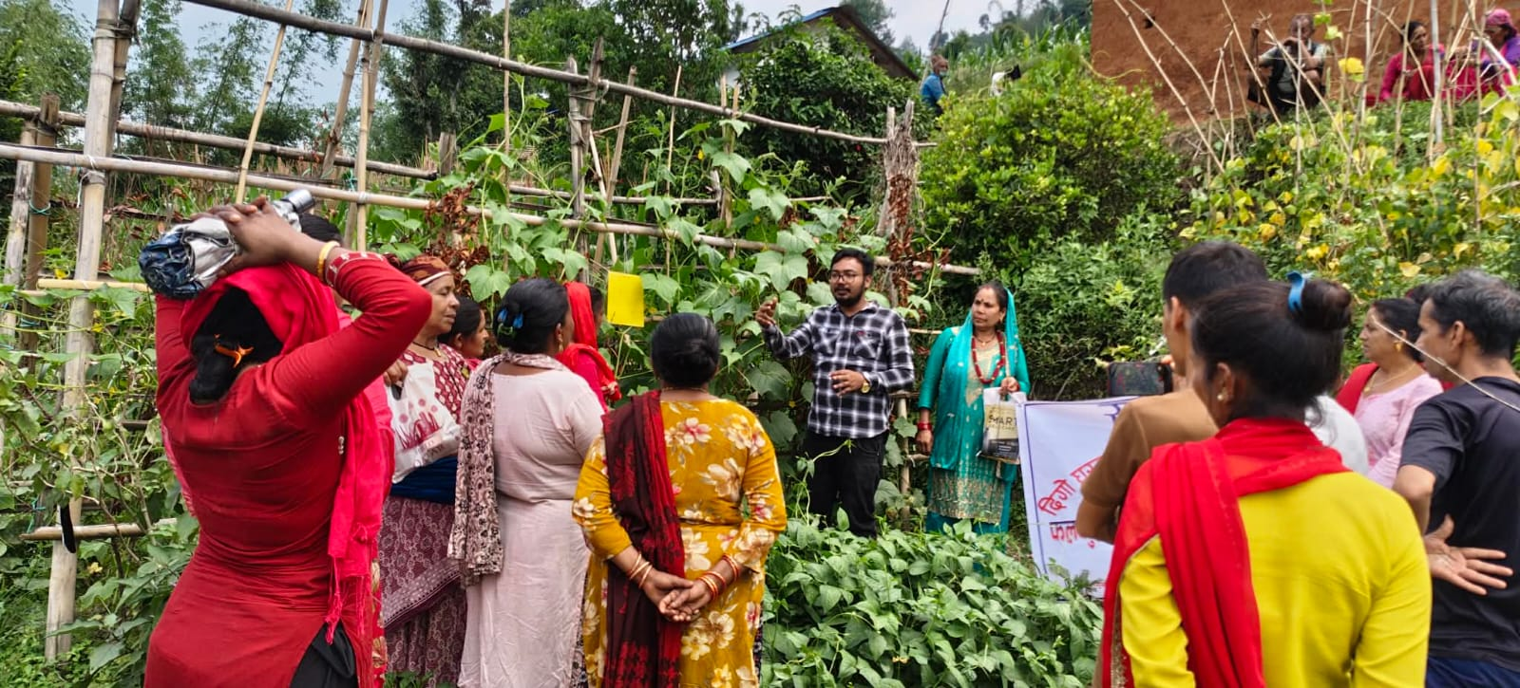
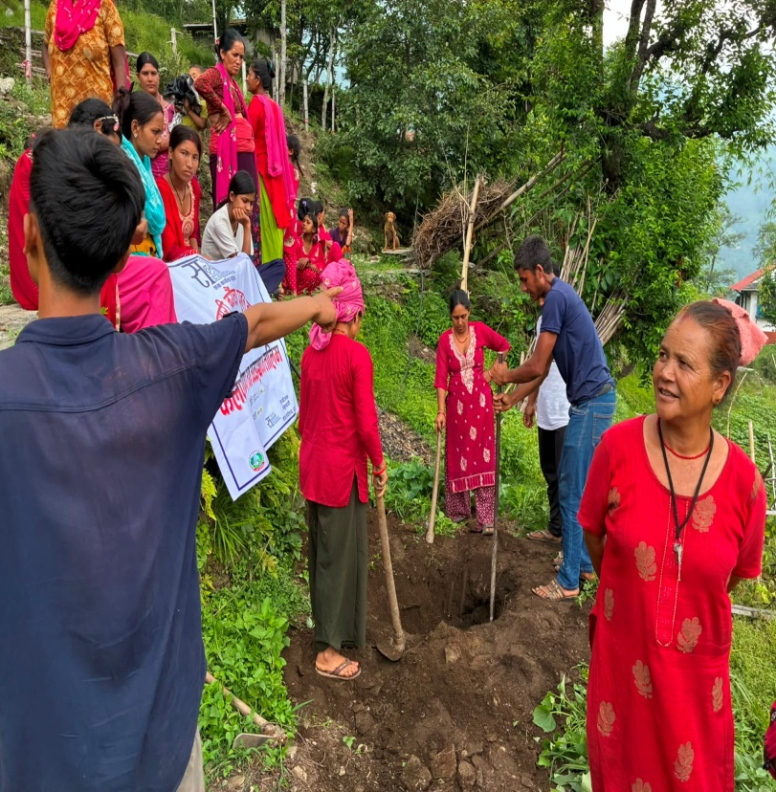
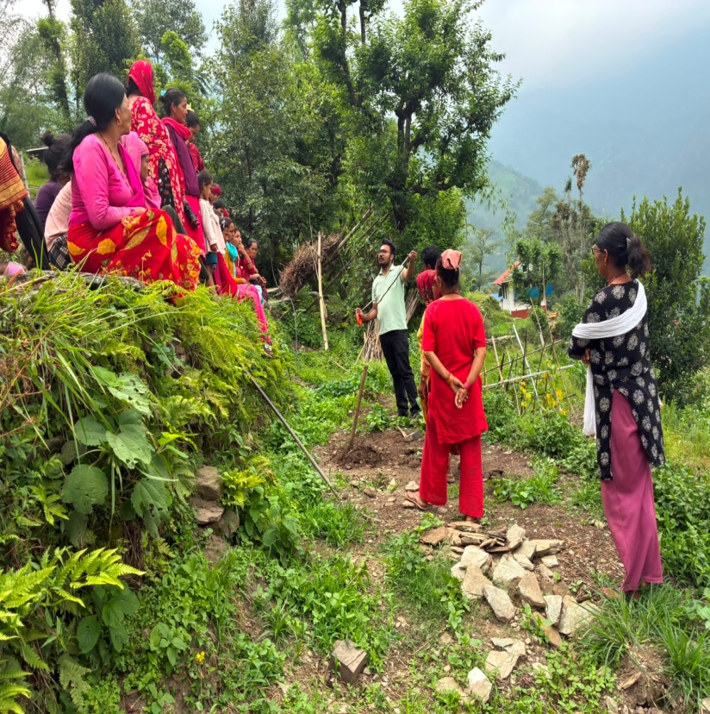

Field Demonstration

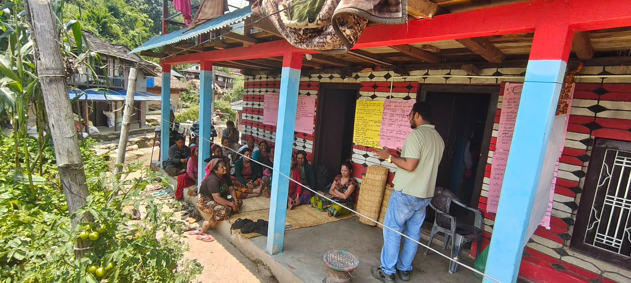
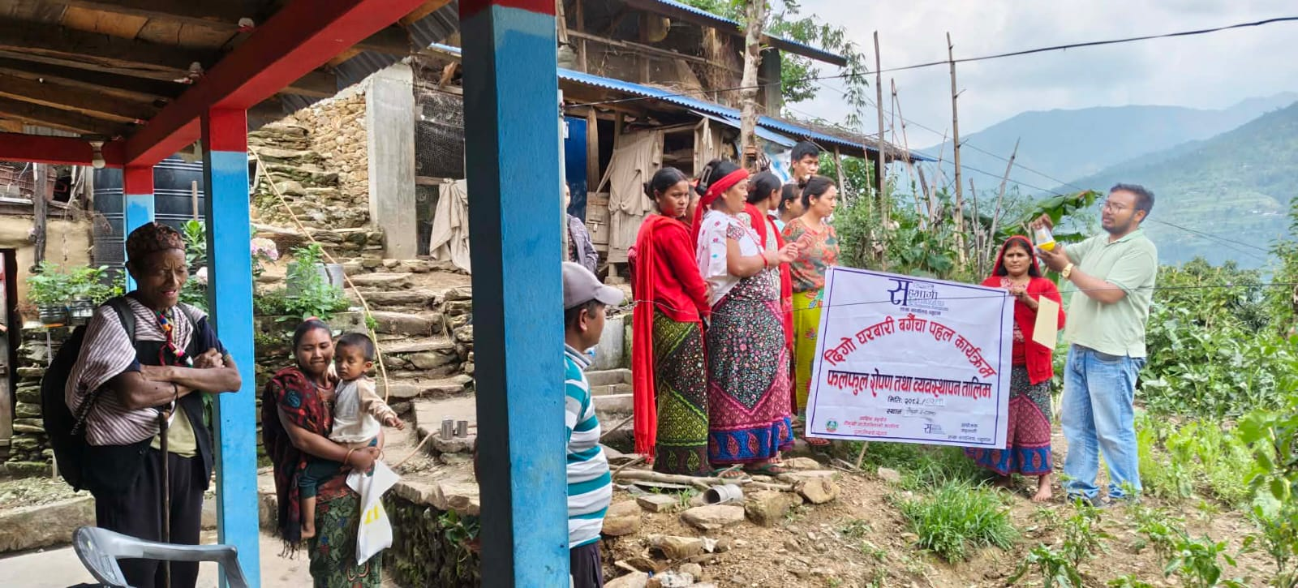
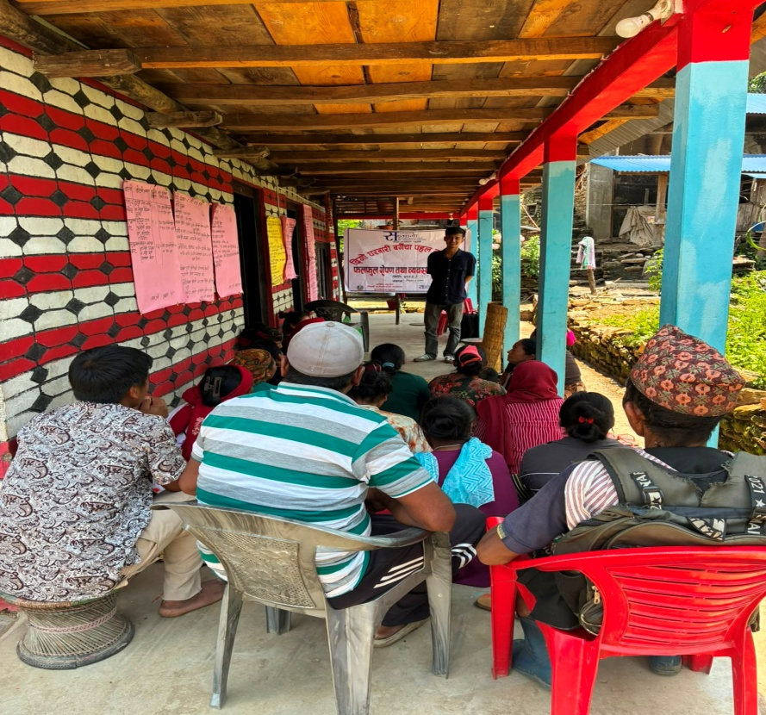
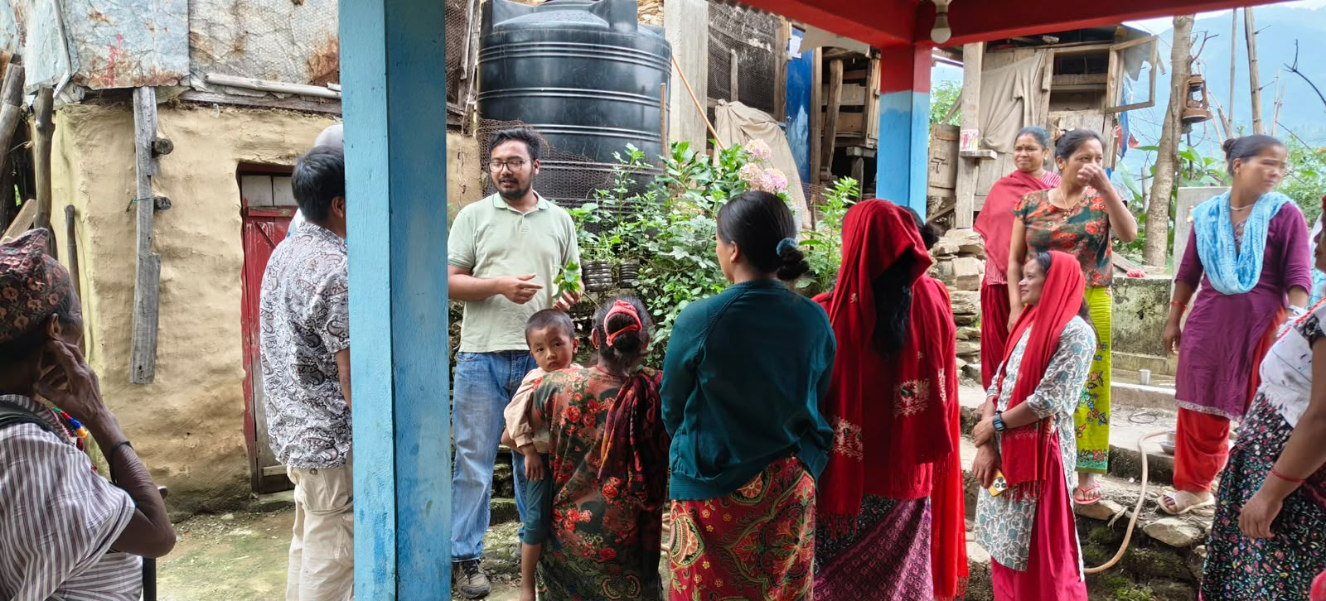
A glimpse of training at Rajwara, Gaumukhi-3

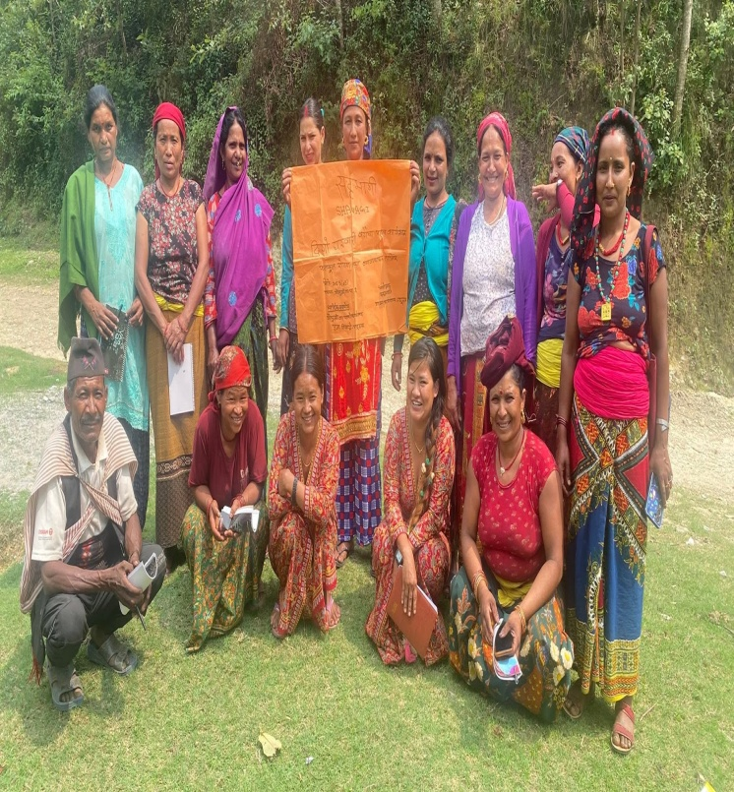
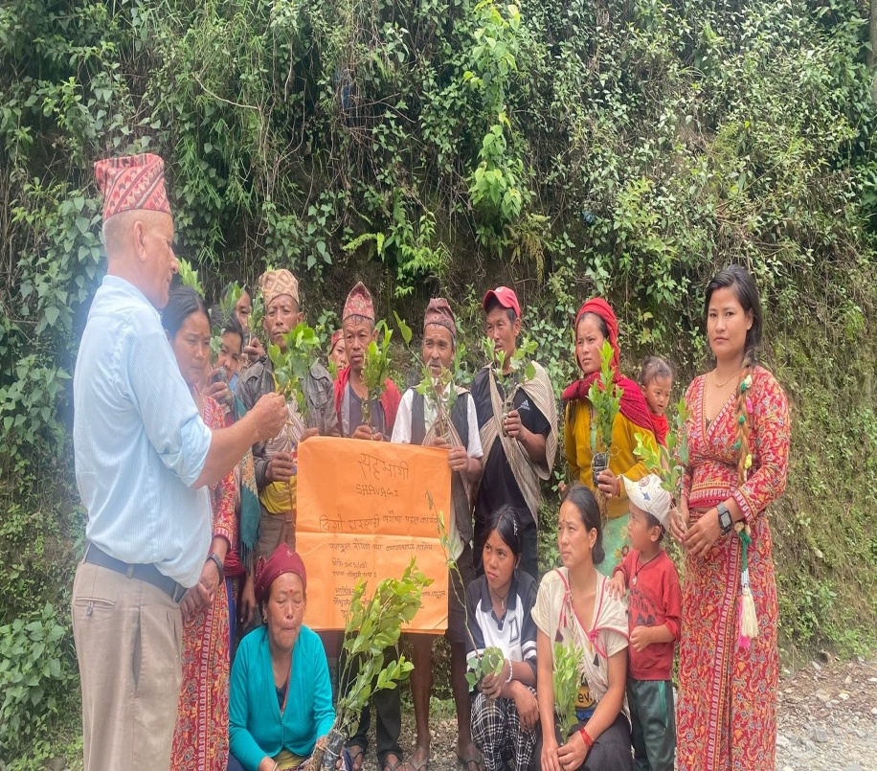
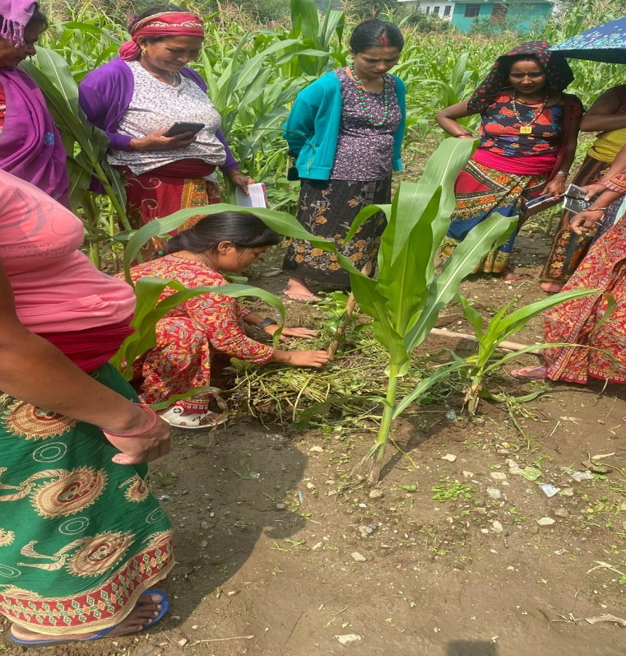
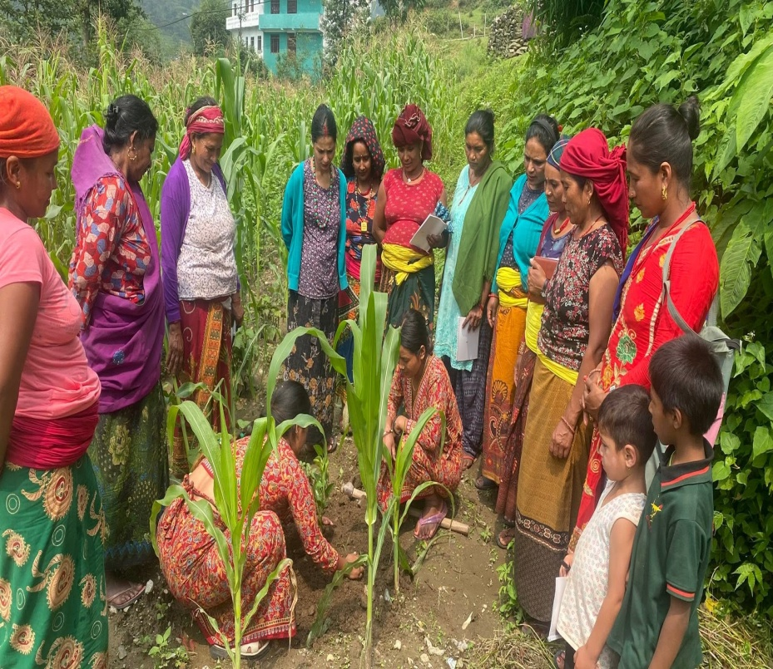
A glimpse of training at Arkha, Gaumukhi-2
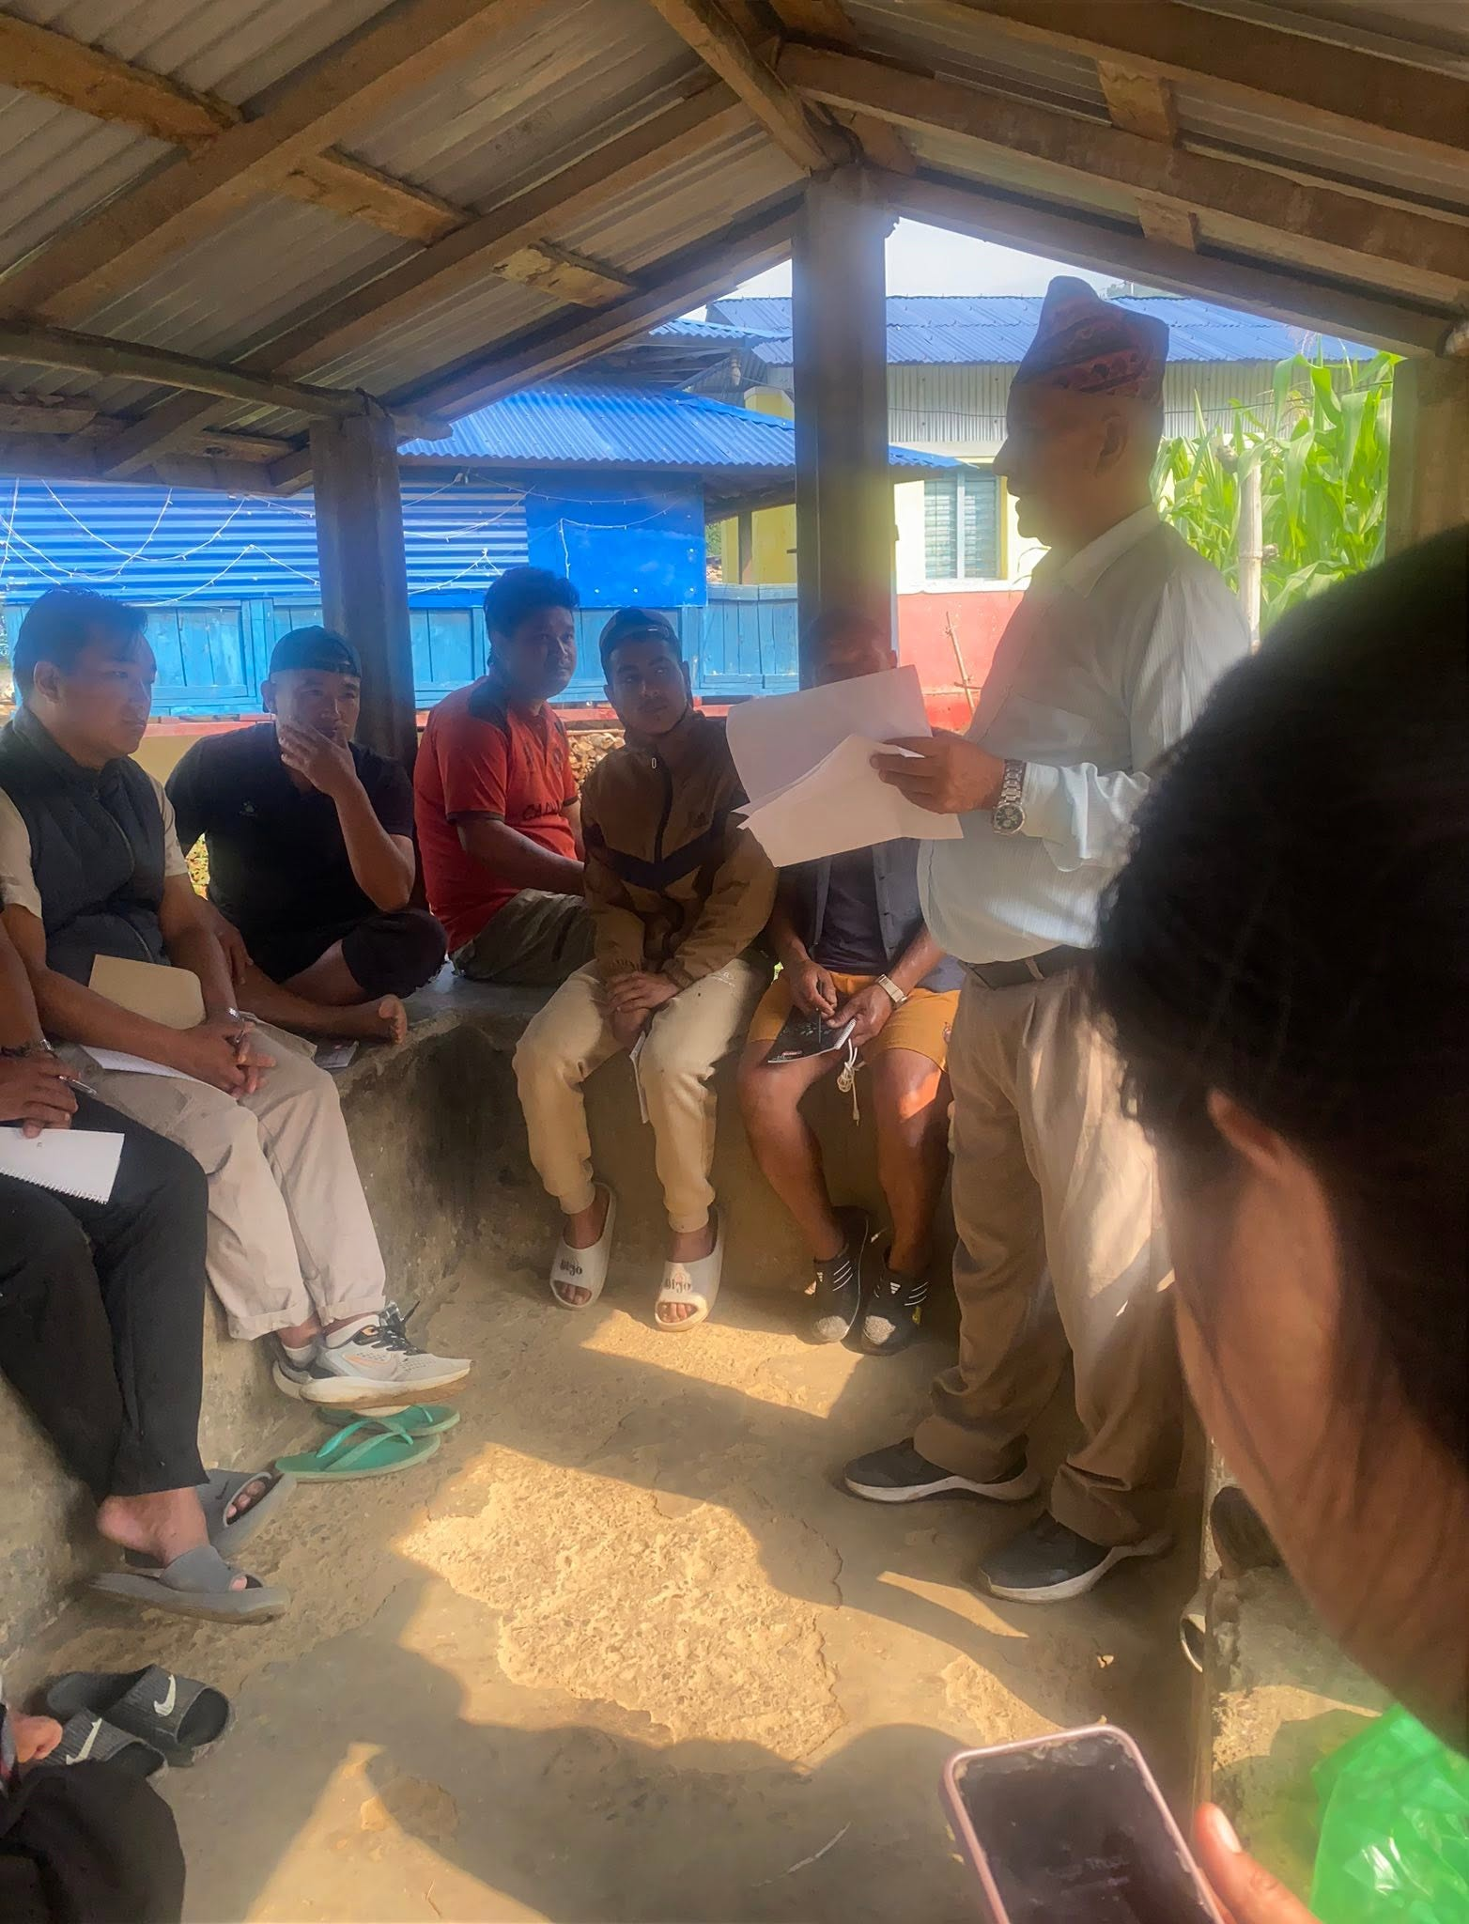
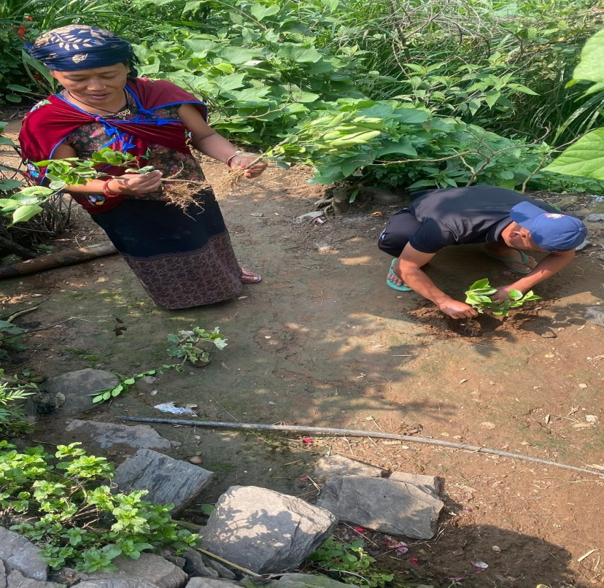
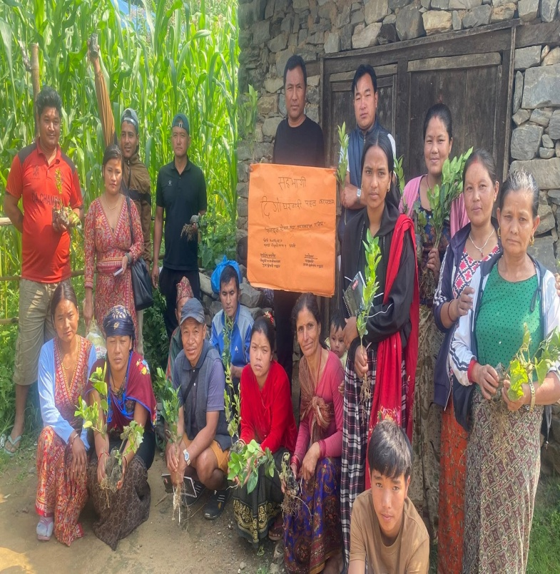
A glimpse of training at Arkha, Gaumukhi-1

